

INJIBARA UNIVERSITY

COLLEGE OF ENGINEERING AND

TECHNOLOGY

DEPARTMENT OF INFORMATION SYSTEM

EVENT DRIVEN PROGRAMMING

INJIBARA UNIVERSITY CLASS SCHEDULING SYSTEM

TABLE CONTENT

ABSTRACT 3
CHAPTER ONE 4
INTRODUCTION 4
1.1 Background of the Study 4
1.1.1 Background of the Organization (Injibara University) 5
1.2 Statement of the Problem 5
1.3 Motivation of the Study 6
1.4 Objectives of the Study 6
1.5 Scope of the Study 7
1.6 Limitations of the Study 8
1.7 Significance of the Study 8
CHAPTER TWO 8
METHODOLOGY 8
2.1 Research Design 8
2.2 Data Collection Methods 9
2.3 System Analysis 9
2.3.1 Functional Requirements 10
2.3.2 Non-Functional Requirements 10
2.4 System Modeling 10
2.5 Access Control and Security 14
CHAPTER THREE 15
SYSTEM IMPLEMENTATION 15
3.1 Introduction 15
3.2 Development Environment 15
3.3 System Architecture 15
3.4 Database Implementation 16
3.5 Major System Modules 16
3.6 User Interface Description 16
3.7 System Testing 17
CHAPTER FOUR 17
CONCLUSION AND RECOMMENDATION 17
4.1 Conclusion 17
4.2 Recommendation 17
REFERENCES 18

ABSTRACT
Class scheduling is a vital academic process that requires accurate planning and effective resource management in higher education institutions. At Injibara University, the traditional manual and semi-manual scheduling methods have resulted in scheduling conflicts, inefficient resource utilization, data inconsistency, and delays in schedule dissemination. To address these challenges, this project develops a desktop-based Class Scheduling System using C#.NET and a SQL Server relational database. The system automates schedule creation and management while enforcing role-based access control to ensure secure and authorized use. Department heads are responsible for creating, updating, and deleting schedules, instructors can view their assigned teaching schedules, and students are allowed read-only access to class schedules. The system stores academic data in a centralized database and incorporates basic conflict validation to reduce time and room overlaps. The proposed solution improves scheduling accuracy, enhances data reliability, reduces manual workload, and increases overall efficiency in academic schedule management.

CHAPTER ONE

INTRODUCTION

1.1 Background of the Study
The rapid advancement of information technology has significantly transformed the way organizations operate, particularly within the education sector. Universities manage large volumes of academic information, including student records, course details, instructor assignments, classroom allocations, and academic schedules. Among these tasks, class scheduling remains one of the most complex and critical operational activities.
Class scheduling involves assigning courses to instructors, allocating suitable classrooms, and determining appropriate time periods while minimizing conflicts and ensuring efficient utilization of resources. When handled manually, this process is prone to errors, inefficiencies, and delays.
In Injibara University, the increasing number of students, academic programs, and instructors has made traditional scheduling methods inadequate. Scheduling is largely performed manually or with basic tools such as spreadsheets, resulting in frequent conflicts and administrative challenges. Therefore, there is a strong need for an automated, secure, and efficient class scheduling system developed using C#.NET and a relational database.

1.1.1 Background of the Organization (Injibara University)
Injibara University is one of Ethiopia’s public higher education institutions established to provide quality education, research, and community service. The university offers various undergraduate and postgraduate programs through multiple academic departments.
As the institution continues to grow, the complexity of managing academic schedules has increased significantly. Currently, scheduling activities are conducted manually, which makes the process time-consuming, error-prone, and difficult to manage. A centralized and automated scheduling system is therefore essential to improve academic administration and operational efficiency.

1.2 Statement of the Problem
At Injibara University, the existing class scheduling process is largely handled using manual or semi-manual methods such as paper-based records and basic spreadsheet tools. As the number of students, instructors, and academic programs continues to increase, this traditional approach has become increasingly inefficient and difficult to manage.
The current system is highly prone to human error, which often results in scheduling conflicts related to time slots, classroom allocation, and instructor availability. Managing instructor workloads is also challenging, leading to uneven teaching assignments and possible overlaps. In addition, updating schedules and communicating changes to students and instructors is time-consuming, causing delays and confusion.
Furthermore, the absence of a secure and centralized database makes data management unreliable and vulnerable to loss or unauthorized access. There is limited role-based access control, which means that users may access information beyond their responsibilities. The lack of an efficient mechanism for rescheduling and modifying existing schedules further reduces the system’s effectiveness.
These challenges negatively impact students, instructors, and department heads by causing wasted time, dissatisfaction, reduced productivity, and inefficient use of academic resources. Therefore, there is a strong need for an automated, secure, and role-based class scheduling system to improve accuracy, efficiency, and overall academic administration at Injibara University.

1.3 Motivation of the Study
The motivation for this study arises from:
- The need to address real-world scheduling challenges
- The desire to minimize errors and reduce manual workload
- The importance of data security and controlled system access
- The opportunity to apply modern software development tools
- The need to develop a practical desktop-based system using C#.NET and SQL Server
Additionally, this project provides practical experience in system analysis, database design, and desktop application development.

1.4 Objectives of the Study

1.4.1 General Objective
To design and develop a desktop-based class scheduling system for Injibara University .

1.4.2 Specific Objectives
The specific objectives of this project are to:
- Evaluate the existing class scheduling practices at Injibara University
- Identify system requirements and user needs through analysis of current procedures
- Design and implement a secure and centralized relational database system
- Develop and test a desktop-based class scheduling application using C#.NET
- Implement role-based access control to ensure secure and authorized system usage
- Enable department heads to create, update, and manage class schedules efficiently
- Allow instructors to view their assigned teaching schedules
- Allow students to view class schedules in a read-only manner
- Minimize scheduling conflicts related to time, room, and instructor allocation
- Improve overall system efficiency, data accuracy, and reliability

1.5 Scope of the Study
The scope of this study is limited to the development of a desktop-based class scheduling system with role-based access control. The system supports course scheduling, instructor assignment, classroom allocation, and schedule viewing. SQL Server is used for database management.
The system does not include:
- Student enrollment management
- Web-based or mobile access
- Advanced optimization or artificial intelligence techniques

1.6 Limitations of the Study
The limitations of the system include:
- Accessibility limited to desktop computers
- No browser-based or mobile platform support
- Absence of advanced automated scheduling algorithms
- Deployment restricted to local university computers
- We have not Validate A room to Assign in different schedules at a time

1.7 Significance of the Study
This system improves scheduling accuracy, reduces conflicts between instructors and students, enhances administrative efficiency, saves time and labor, strengthens data security, and provides a foundation for future system expansion.

CHAPTER TWO

METHODOLOGY

2.1 Research Design
The study adopts a system development research design, focusing on analyzing the existing scheduling process, designing a computerized solution, and implementing a functional desktop application.

2.2 Data Collection Methods

2.2.1 Interviews
Interviews were conducted with department heads, academic coordinators, and administrative staff to:
- Understand current scheduling practices
- Identify challenges and scheduling conflicts
- Gather system requirements and expectations

2.2.2 Observation
Direct observation was used to study how schedules are created, modified, and distributed. This helped identify inefficiencies, delays, and errors in the manual system.

2.2.3 Document Review
Relevant documents such as academic calendars, course catalogs, and existing schedules were reviewed to understand scheduling formats and institutional policies.

2.3 System Analysis
Analysis revealed that the existing scheduling system is largely manual, leading to frequent conflicts, inefficient updates, poor data security, and unreliable record management.
System requirements were categorized into functional and non-functional requirements.

2.3.1 Functional Requirements
The system shall:
- Authenticate users using secure login credentials
- Enforce role-based authorization (Department Head, Instructor, Student)
- Allow department heads to create, update, and delete schedules
- Allow instructors to view their schedules
- Allow students to view class schedules
- Store and retrieve data securely from the database

2.3.2 Non-Functional Requirements
The system shall be:
- Secure: Protect sensitive data from unauthorized access
- Reliable: Operate consistently with minimal failure
- Usable: Easy to navigate and user-friendly
- Efficient: Respond quickly to user requests

2.4 System Modeling

2.4.1 Use Case Diagram
The use case diagram illustrates interactions between users and system features such as login, schedule management, and schedule viewing.

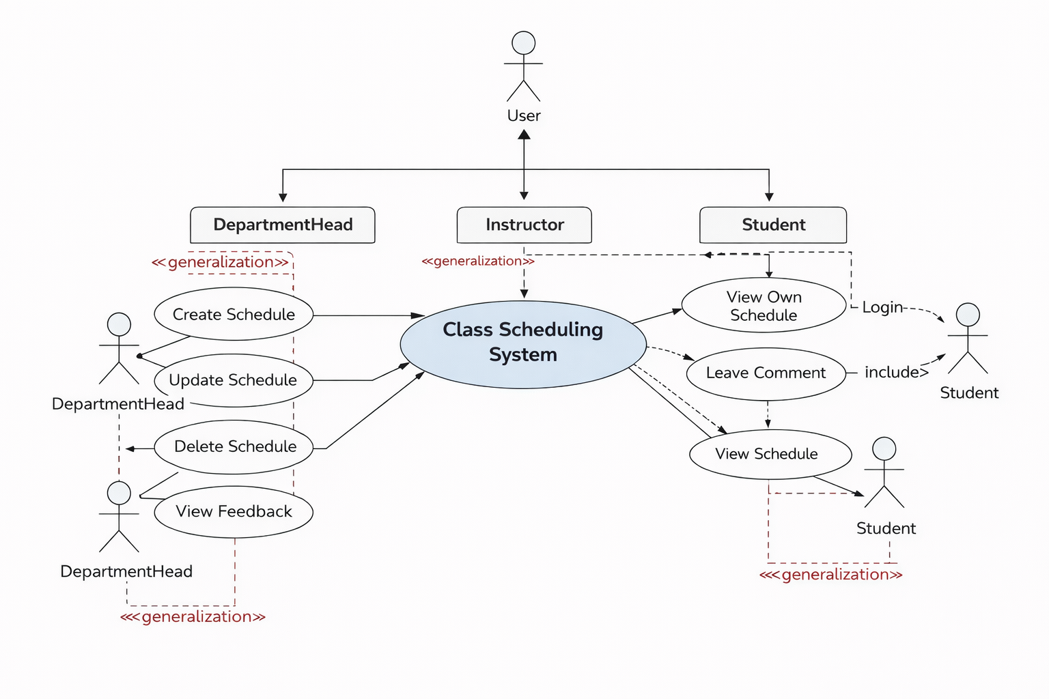

Figure 1:Use case diagram

2.4.2 Entity Relationship Diagram (ERD)
The ERD defines relationships among Users, Courses, Instructors, Rooms, and Schedules, ensuring database normalization and data integrity.

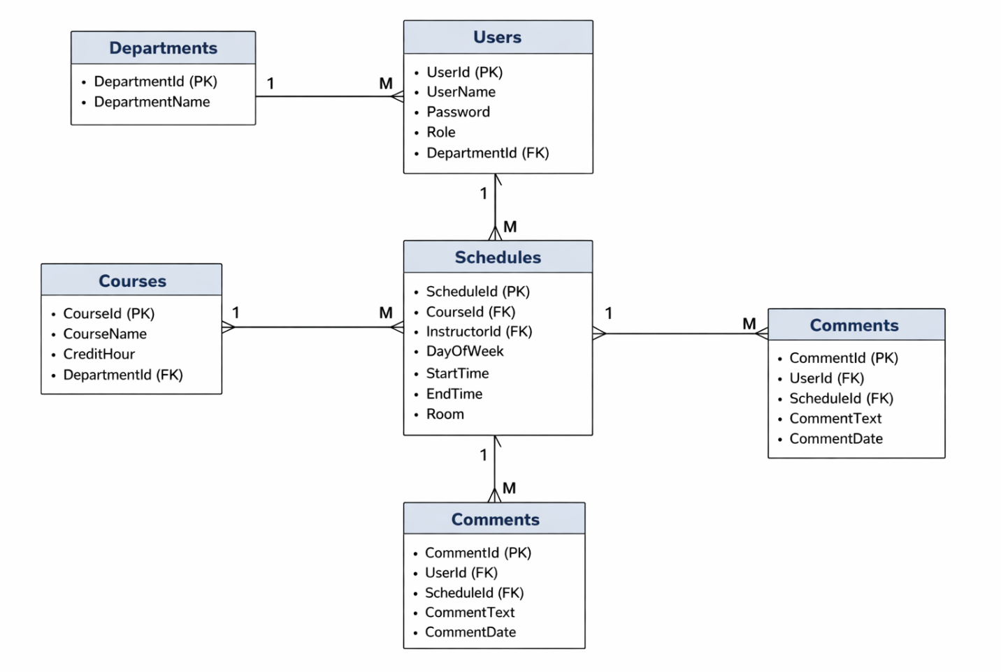

Figure 2:Entity Relation diagram

2.4.3 Data Flow Diagram (DFD)
DFDs show how data flows from user input through processing to database storage and output.

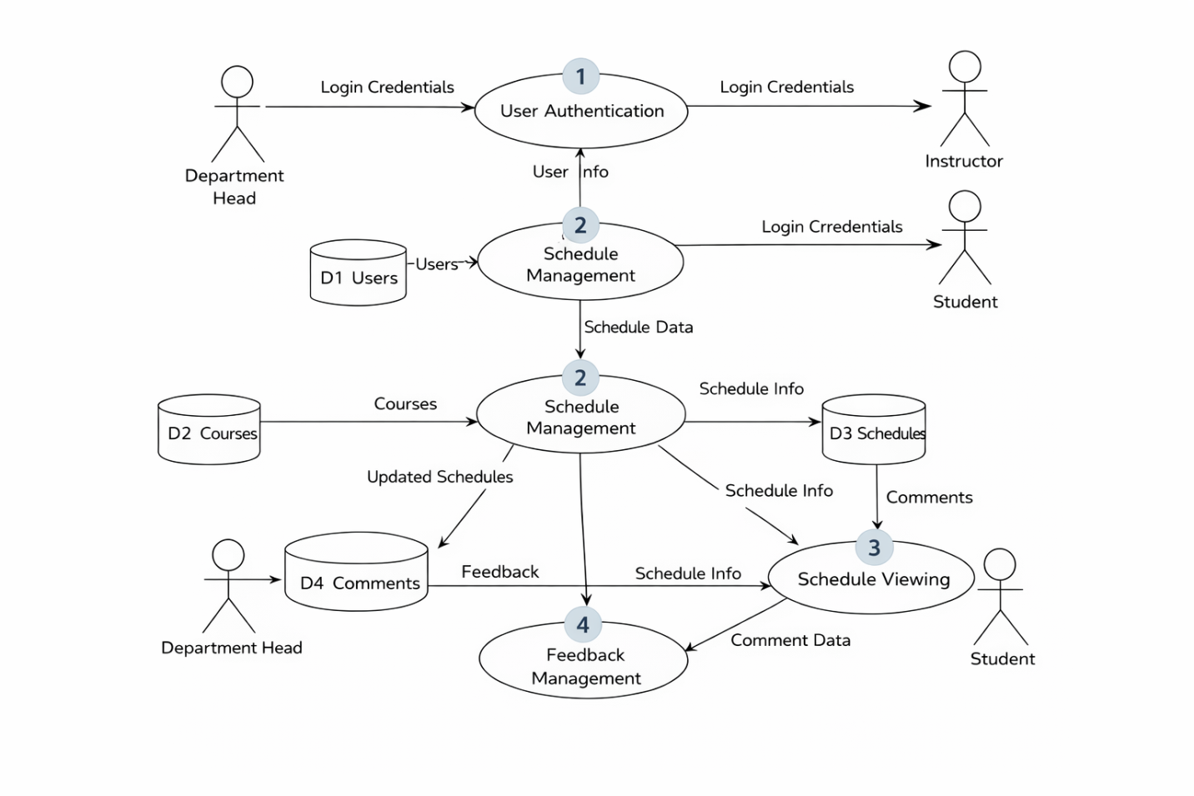

Figure 3:Data Flow diagram

2.4.4 System Architecture Diagram
The system follows a three-tier architecture consisting of presentation, business logic, and data access layers.
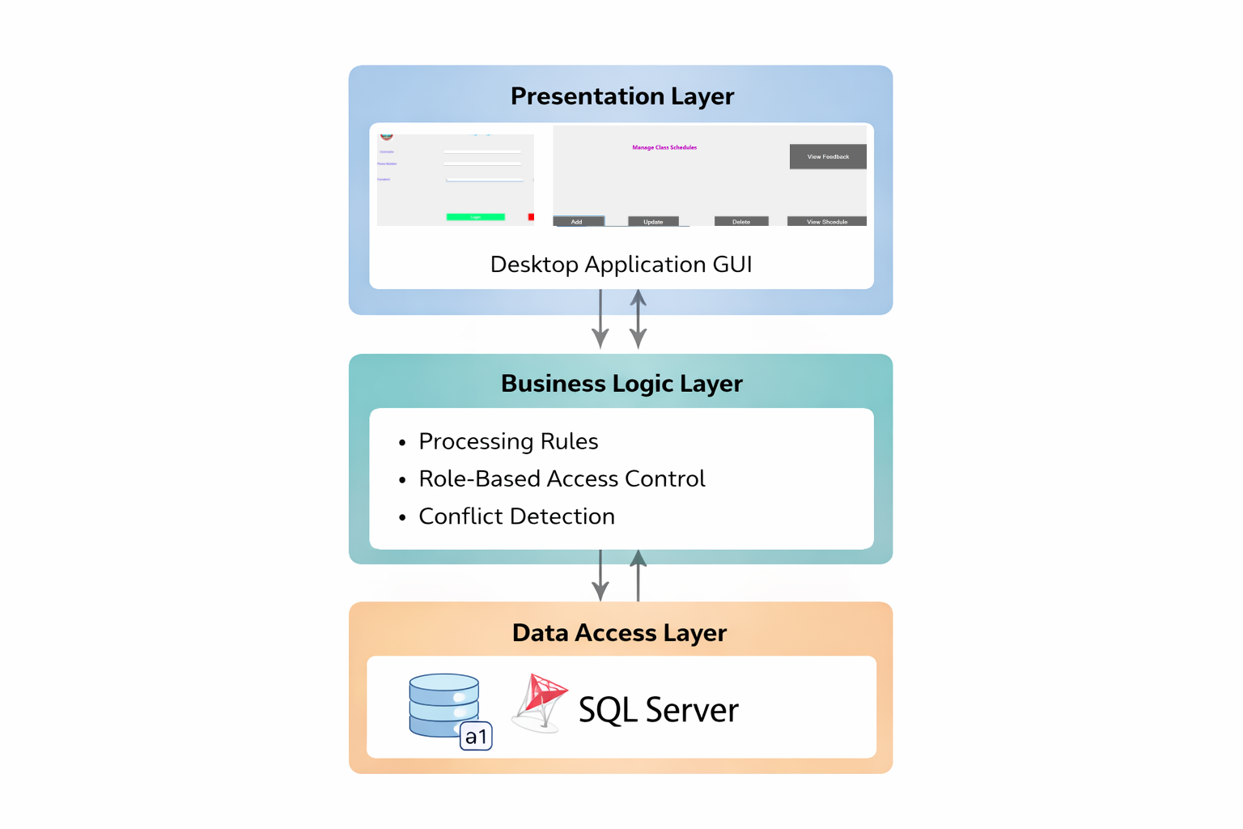

Figure 4:System Archtecture diagram

2.5 Access Control and Security
The system implements Role-Based Access Control (RBAC):

Role | Access Level
Department Head | Full schedule management
Instructor | View own schedules
Student | View schedules

Table 1:Role and Actors Table

Security mechanisms include:
- Secure authentication
- Input validation
- Controlled database access

CHAPTER THREE

SYSTEM IMPLEMENTATION

3.1 Introduction
This chapter describes system implementation details including tools, architecture, database design, modules, and interfaces.

3.2 Development Environment
- Programming Language: C#
- Framework: .NET Framework
- IDE: Visual Studio
- Database: SQL Server
- OS: Windows

3.3 System Architecture
The system uses a three-tier architecture:
- Presentation Layer (Forms & UI)
- Business Logic Layer
- Data Access Layer

3.4 Database Implementation

3.4.1 Main Tables
- Users
- Courses
- Departments
- Schedules
- Comments

3.4.2 Relationships
- One instructor teaches multiple courses
- One room hosts many schedules at different times
- One schedule links course, instructor, room, and time

3.5 Major System Modules
- Authentication Module
- Schedule Management Module
- Schedule Viewing Module
- Feedback Module

3.6 User Interface Description
Screens include:
- Login form
- Department Head dashboard
- Instructor schedule view
- Student schedule view
- Feedback viewing interface

3.7 System Testing
Testing types:
- Unit testing
- Integration testing
- System testing

CHAPTER FOUR

CONCLUSION AND RECOMMENDATION

4.1 Conclusion
The developed Class Scheduling System for Injibara University has proven to be an effective and comprehensive solution for managing academic schedules. By automating the scheduling process, the system significantly reduces the likelihood of conflicts between courses, instructors, and classrooms, which are common challenges in traditional manual scheduling methods. The implementation of role-based access control ensures that sensitive data is protected, allowing students, instructors, and department heads to access only the information relevant to their roles, thereby enhancing overall data security. Moreover, the system streamlines administrative tasks, minimizes manual errors, and improves communication among all stakeholders, contributing to a more organized and efficient academic environment. The enhanced operational efficiency provided by the system not only saves time for students and faculty but also supports better resource management within the university. Overall, this system represents a strategic improvement in the management of academic schedules, promoting a more structured, secure, and user-friendly approach that aligns with the university’s goals of academic excellence and operational effectiveness.

4.2 Recommendation
Future enhancements may include:
- Web-based system development
- Mobile access
- Advanced scheduling optimization
- Integration with student enrollment systems

REFERENCES
- Pressman, R. S. (2014). Software Engineering: A Practitioner’s Approach
- Microsoft C# .NET Documentation
- SQL Server Documentation

